With the increasing popularity of e-books in the last decade, the CIS Department at College of Business developed the Free Access to Current Technology (FACT) library of ebooks. FACT is a collection of current technology ebooks for use by faculty and students. The department is wondering if the library was used enough, and if it was, they would update the books. The department needs your help in analyzing this historical data. Agreements with the publishers allow patrons to electronically check out a book, which gives them exclusive access to the book online through the FACT website, but only one patron at a time can have access to a book. A book must have at least one author but can have many. An author must have written at least one book to be included in the system, but may have written many. A book may have never been checked out, but can be checked out many times by the same patron or different patrons over time. Because all faculty and staff in the department are given accounts at the online library, a patron may have never checked out a book or they may have checked out many books over time. To simplify determining which patron currently has a given book checked out, a redundant relationship between BOOK and PATRON is maintained. The ERD for this system is shown at the bottom of this document and should be used to answer Problems presented here. For these problems, a figure of the correct output is provided for each problem. If the output of the query is very large, only the first several rows of the output are shown.

1. Write a query that displays the book title, cost and year of publication for every book in the system.

SQL:

1. Write a query that displays the first and last name of every patron.

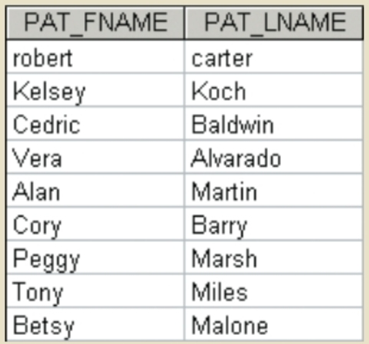

SQL:

1. Write a query to display the checkout number, checkout date, and due date for every book that has been checked out.

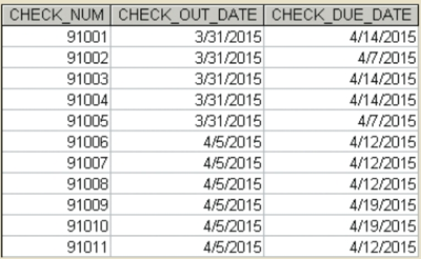

SQL:

1. Write a query to display the book number, book title, and year of publication for every book.

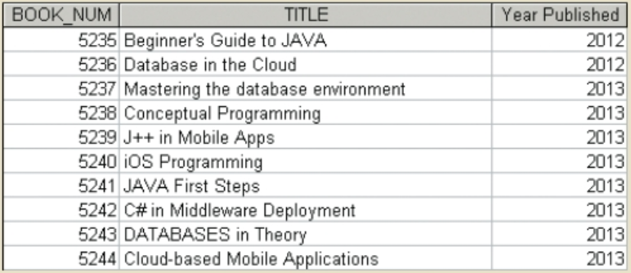

SQL:

1. Write a query to display the different years in which books have been published. Include each year only once.

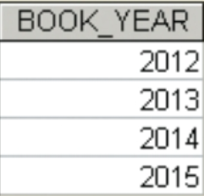

SQL:

1. Write a query to display the different subjects on which FACT has books. Include each subject only once.

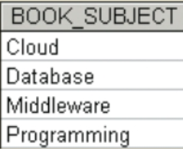

SQL:

1. Write a query to display the book number, title, and cost of each book.

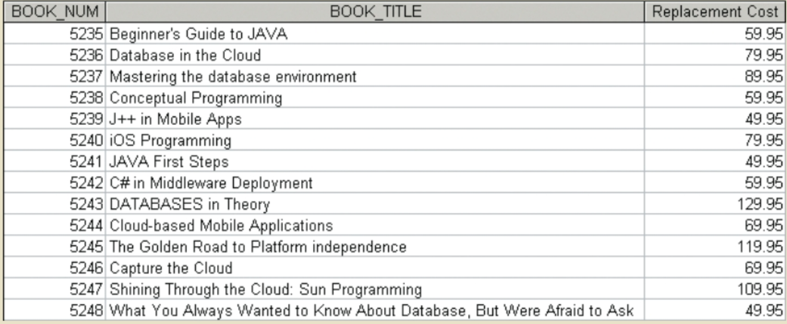

SQL:

1. Write a query to display the checkout number, book number, patron ID, checkout date, and due date for every checkout that has ever occurred in the system. Sort the results by checkout date in descending order.

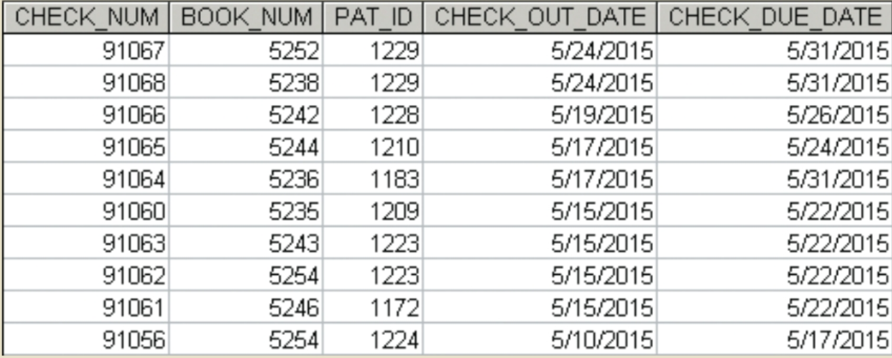

SQL:

1. Write a query to display the book title, year, and subject for every book. Sort the results by book subject in ascending order, year in descending order, and then title in ascending order.

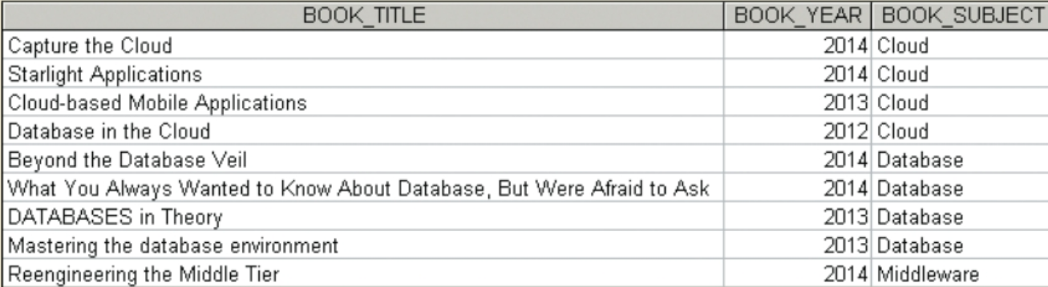

SQL:

1. Write a query to display the book number, title, and year of publication for all books published in 2012.

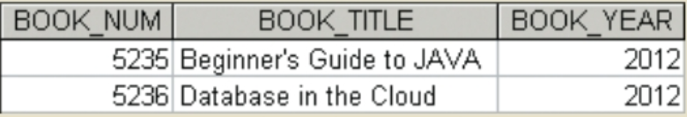

SQL:

1. Write a query to display the book number, title, and year of publication for all books in the “Database” subject.

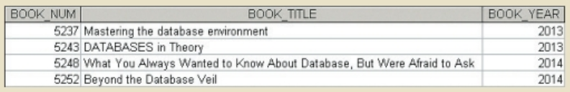

SQL:

1. Write a query to display the checkout number, book number, and checkout date of all books checked out before April 5, 2015.

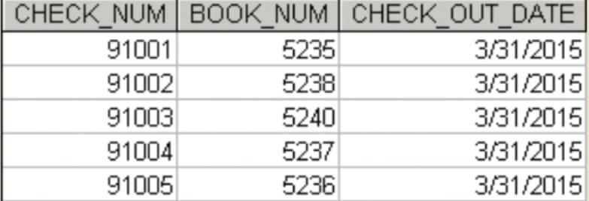

SQL:

1. Write a query to display the book number, title, and year of publication of all books published after 2013 and on the “Programming” subject.

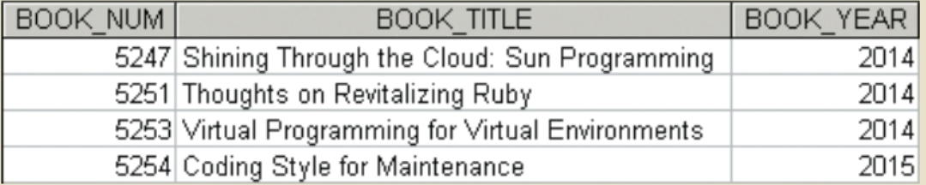

SQL:

1. Write a query to display the book number, title, year of publication, subject, and cost for all books that are on the subjects of “Middleware” or “Cloud,” and that cost more than $70.

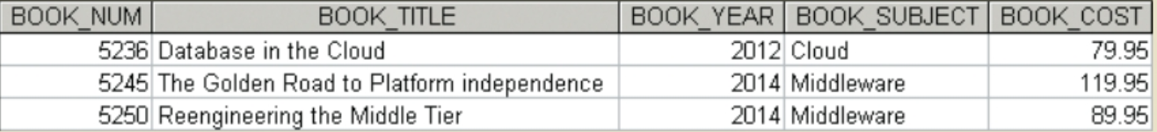

SQL:

1. Write a query to display the author ID, first name, last name, and year of birth for all authors born in the decade of the 1980s.

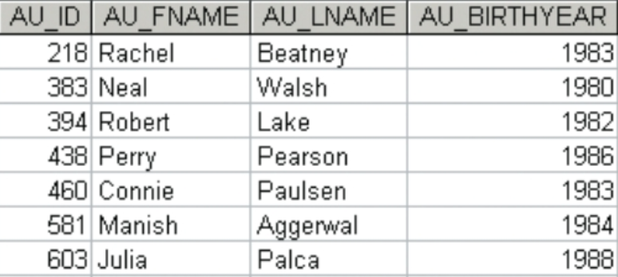

SQL:

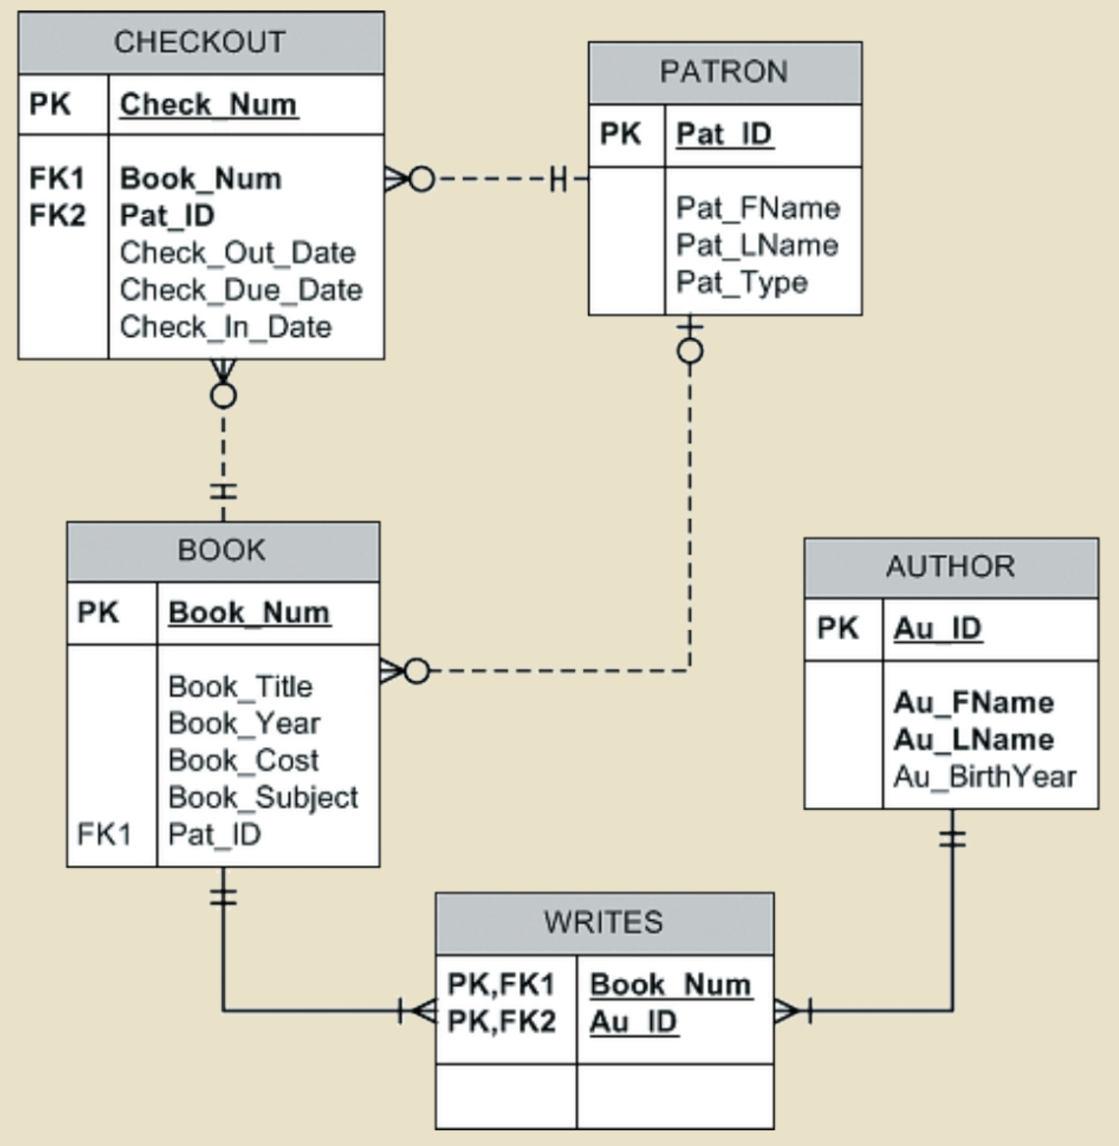

**Queries**

CREATE TABLE AUTHOR (

AU_ID NUMERIC(7,0) PRIMARY KEY,

AU_FNAME VARCHAR(30) NOT NULL ,

AU_LNAME VARCHAR(30) NOT NULL ,

AU_BIRTHYEAR NUMERIC(4)

);

CREATE TABLE PATRON (

PAT_ID NUMERIC(10,0) PRIMARY KEY,

PAT_FNAME VARCHAR(20) NOT NULL ,

PAT_LNAME VARCHAR(20) NOT NULL ,

PAT_TYPE VARCHAR(10) NOT NULL

);

CREATE TABLE BOOK (

BOOK_NUM NUMERIC(10,0) PRIMARY KEY,

BOOK_TITLE VARCHAR(120) NOT NULL ,

BOOK_YEAR NUMERIC(4) ,

BOOK_COST NUMERIC(8,2) ,

BOOK_SUBJECT VARCHAR(120) ,

PAT_ID NUMERIC(10) REFERENCES PATRON

);

CREATE TABLE CHECKOUT (

CHECK_NUM NUMERIC(15) PRIMARY KEY,

BOOK_NUM NUMERIC(10) REFERENCES BOOK,

PAT_ID NUMERIC(10) REFERENCES PATRON,

CHECK_OUT_DATE DATE DEFAULT GETDATE(),

CHECK_DUE_DATE DATE,

CHECK_IN_DATE DATE

);

CREATE TABLE WRITES (

BOOK_NUM NUMERIC(10) REFERENCES BOOK,

AU_ID NUMERIC(7) REFERENCES AUTHOR,

CONSTRAINT WRITES_BOOK_AU_PK PRIMARY KEY (BOOK_NUM, AU_ID)

);

--AUTHOR rows

INSERT INTO AUTHOR VALUES (185, 'Benson', 'Reeves', 1990);

INSERT INTO AUTHOR VALUES (218, 'Rachel', 'Beatney', 1983);

INSERT INTO AUTHOR VALUES (229, 'Carmine', 'Salvadore', NULL);

INSERT INTO AUTHOR VALUES (251, 'Hugo', 'Bruer', 1972);

INSERT INTO AUTHOR VALUES (262, 'Xia', 'Chiang', NULL);

INSERT INTO AUTHOR VALUES (273, 'Reba', 'Durante', 1969);

INSERT INTO AUTHOR VALUES (284, 'Trina', 'Tankersly', 1961);

INSERT INTO AUTHOR VALUES (383, 'Neal', 'Walsh', 1980);

INSERT INTO AUTHOR VALUES (394, 'Robert', 'Lake', 1982);

INSERT INTO AUTHOR VALUES (438, 'Perry', 'Pearson', 1986);

INSERT INTO AUTHOR VALUES (460, 'Connie', 'Paulsen', 1983);

INSERT INTO AUTHOR VALUES (559, 'Rachel', 'McGill', NULL);

INSERT INTO AUTHOR VALUES (581, 'Manish', 'Aggerwal', 1984);

INSERT INTO AUTHOR VALUES (592, 'Lawrence', 'Sheel', 1976);

INSERT INTO AUTHOR VALUES (603, 'Julia', 'Palca', 1988);

--PATRON rows

INSERT INTO PATRON VALUES (1160, 'robert', 'carter', 'Faculty');

INSERT INTO PATRON VALUES (1161, 'Kelsey', 'Koch', 'Faculty');

INSERT INTO PATRON VALUES (1165, 'Cedric', 'Baldwin', 'Faculty');

INSERT INTO PATRON VALUES (1166, 'Vera', 'Alvarado', 'Student');

INSERT INTO PATRON VALUES (1167, 'Alan', 'Martin', 'FACULTY');

INSERT INTO PATRON VALUES (1170, 'Cory', 'Barry', 'faculty');

INSERT INTO PATRON VALUES (1171, 'Peggy', 'Marsh', 'STUDENT');

INSERT INTO PATRON VALUES (1172, 'Tony', 'Miles', 'STUDENT');

INSERT INTO PATRON VALUES (1174, 'Betsy', 'Malone', 'STUDENT');

INSERT INTO PATRON VALUES (1180, 'Nadine', 'Blair', 'STUDENT');

INSERT INTO PATRON VALUES (1181, 'Allen', 'Horne', 'Student');

INSERT INTO PATRON VALUES (1182, 'Jamal', 'Melendez', 'STUDENT');

INSERT INTO PATRON VALUES (1183, 'Helena', 'Hughes', 'Faculty');

INSERT INTO PATRON VALUES (1184, 'Jimmie', 'Love', 'StudenT');

INSERT INTO PATRON VALUES (1185, 'Sandra', 'Yang', 'student');

INSERT INTO PATRON VALUES (1200, 'Lorenzo', 'Torres', 'Student');

INSERT INTO PATRON VALUES (1201, 'Shelby', 'Noble', 'Student');

INSERT INTO PATRON VALUES (1202, 'Holly', 'Anthony', 'Student');

INSERT INTO PATRON VALUES (1203, 'Tyler', 'Pope', 'STUDENT');

INSERT INTO PATRON VALUES (1204, 'Thomas', 'Duran', 'Student');

INSERT INTO PATRON VALUES (1205, 'Claire', 'Gomez', 'student');

INSERT INTO PATRON VALUES (1207, 'Iva', 'Ramos', 'Student');

INSERT INTO PATRON VALUES (1208, 'Ollie', 'Cantrell', 'Student');

INSERT INTO PATRON VALUES (1209, 'Rena', 'Mathis', 'Student');

INSERT INTO PATRON VALUES (1210, 'Keith', 'Cooley', 'STUdent');

INSERT INTO PATRON VALUES (1211, 'Jerald', 'Gaines', 'Student');

INSERT INTO PATRON VALUES (1212, 'Iva', 'McClain', 'Student');

INSERT INTO PATRON VALUES (1213, 'Desiree', 'Rivas', 'Student');

INSERT INTO PATRON VALUES (1214, 'Marina', 'King', 'Student');

INSERT INTO PATRON VALUES (1215, 'Maureen', 'Downs', 'Student');

INSERT INTO PATRON VALUES (1218, 'Angel', 'Terrell', 'Student');

INSERT INTO PATRON VALUES (1219, 'Desiree', 'Harrington', 'Student');

INSERT INTO PATRON VALUES (1220, 'Carlton', 'Morton', 'Student');

INSERT INTO PATRON VALUES (1221, 'Gloria', 'Pitts', 'Student');

INSERT INTO PATRON VALUES (1222, 'Zach', 'Kelly', 'Student');

INSERT INTO PATRON VALUES (1223, 'Jose', 'Hays', 'Student');

INSERT INTO PATRON VALUES (1224, 'Jewel', 'England', 'Student');

INSERT INTO PATRON VALUES (1225, 'Wilfred', 'Fuller', 'Student');

INSERT INTO PATRON VALUES (1226, 'Jeff', 'Owens', 'Student');

INSERT INTO PATRON VALUES (1227, 'Alicia', 'Dickson', 'Student');

INSERT INTO PATRON VALUES (1228, 'Homer', 'Goodman', 'Student');

INSERT INTO PATRON VALUES (1229, 'Gerald', 'Burke', 'Student');

INSERT INTO PATRON VALUES (1237, 'Brandi', 'Larson', 'Student');

INSERT INTO PATRON VALUES (1238, 'Erika', 'Bowen', 'Student');

INSERT INTO PATRON VALUES (1239, 'Elton', 'Irwin', 'Student');

INSERT INTO PATRON VALUES (1240, 'Jan', 'Joyce', 'Student');

INSERT INTO PATRON VALUES (1241, 'Irene', 'West', 'Student');

INSERT INTO PATRON VALUES (1242, 'Mario', 'King', 'Student');

INSERT INTO PATRON VALUES (1243, 'Roberto', 'Kennedy', 'Student');

INSERT INTO PATRON VALUES (1244, 'Leon', 'Richmond', 'Student');

--BOOK rows

INSERT INTO BOOK VALUES (5235, 'Beginner''s Guide to JAVA', 2012, 59.95, 'Programming', NULL);

INSERT INTO BOOK VALUES (5236, 'Database in the Cloud', 2012, 79.95, 'Cloud', NULL);

INSERT INTO BOOK VALUES (5237, 'Mastering the database environment', 2013, 89.95, 'Database', NULL);

INSERT INTO BOOK VALUES (5238, 'Conceptual Programming', 2013, 59.95, 'Programming', 1229);

INSERT INTO BOOK VALUES (5239, 'J++ in Mobile Apps', 2013, 49.95, 'Programming', NULL);

INSERT INTO BOOK VALUES (5240, 'iOS Programming', 2013, 79.95, 'Programming', 1212);

INSERT INTO BOOK VALUES (5241, 'JAVA First Steps', 2013, 49.95, 'Programming', NULL);

INSERT INTO BOOK VALUES (5242, 'C# in Middleware Deployment', 2013, 59.95, 'Middleware', 1228);

INSERT INTO BOOK VALUES (5243, 'DATABASES in Theory', 2013, 129.95, 'Database', NULL);

INSERT INTO BOOK VALUES (5244, 'Cloud-based Mobile Applications', 2013, 69.95, 'Cloud', NULL);

INSERT INTO BOOK VALUES (5245, 'The Golden Road to Platform independence', 2014, 119.95, 'Middleware', NULL);

INSERT INTO BOOK VALUES (5246, 'Capture the Cloud', 2014, 69.95, 'Cloud', 1172);

INSERT INTO BOOK VALUES (5247, 'Shining Through the Cloud: Sun Programming', 2014, 109.95, 'Programming', NULL);

INSERT INTO BOOK VALUES (5248, 'What You Always Wanted to Know About Database, But Were Afraid to Ask', 2014, 49.95, 'Database', NULL);

INSERT INTO BOOK VALUES (5249, 'Starlight Applications', 2014, 69.95, 'Cloud', 1207);

INSERT INTO BOOK VALUES (5250, 'Reengineering the Middle Tier', 2014, 89.95, 'Middleware', NULL);

INSERT INTO BOOK VALUES (5251, 'Thoughts on Revitalizing Ruby', 2014, 59.95, 'Programming', NULL);

INSERT INTO BOOK VALUES (5252, 'Beyond the Database Veil', 2014, 69.95, 'Database', 1229);

INSERT INTO BOOK VALUES (5253, 'Virtual Programming for Virtual Environments', 2014, 79.95, 'Programming', NULL);

INSERT INTO BOOK VALUES (5254, 'Coding Style for Maintenance', 2015, 49.95, 'Programming', NULL);

--CHECKOUT rows

INSERT INTO CHECKOUT VALUES (91001, 5235, 1165, '03/31/2015', '04/14/2015', '04/09/2015');

INSERT INTO CHECKOUT VALUES (91002, 5238, 1209, '03/31/2015', '04/07/2015', '04/05/2015');

INSERT INTO CHECKOUT VALUES (91003, 5240, 1160, '03/31/2015', '04/14/2015', '04/09/2015');

INSERT INTO CHECKOUT VALUES (91004, 5237, 1160, '03/31/2015', '04/14/2015', '04/03/2015');

INSERT INTO CHECKOUT VALUES (91005, 5236, 1202, '03/31/2015', '04/07/2015', '04/08/2015');

INSERT INTO CHECKOUT VALUES (91006, 5235, 1203, '04/05/2015', '04/12/2015', '04/13/2015');

INSERT INTO CHECKOUT VALUES (91007, 5244, 1174, '04/05/2015', '04/12/2015', '04/08/2015');

INSERT INTO CHECKOUT VALUES (91008, 5248, 1181, '04/05/2015', '04/12/2015', '04/06/2015');

INSERT INTO CHECKOUT VALUES (91009, 5242, 1170, '04/05/2015', '04/19/2015', '04/09/2015');

INSERT INTO CHECKOUT VALUES (91010, 5235, 1161, '04/05/2015', '04/19/2015', '04/05/2015');

INSERT INTO CHECKOUT VALUES (91011, 5236, 1181, '04/05/2015', '04/12/2015', '04/11/2015');

INSERT INTO CHECKOUT VALUES (91012, 5249, 1181, '04/08/2015', '04/15/2015', '04/12/2015');

INSERT INTO CHECKOUT VALUES (91013, 5240, 1160, '04/10/2015', '04/24/2015', '04/19/2015');

INSERT INTO CHECKOUT VALUES (91014, 5236, 1204, '04/11/2015', '04/18/2015', '04/19/2015');

INSERT INTO CHECKOUT VALUES (91015, 5237, 1204, '04/11/2015', '04/18/2015', '04/13/2015');

INSERT INTO CHECKOUT VALUES (91016, 5236, 1183, '04/13/2015', '04/27/2015', '04/14/2015');

INSERT INTO CHECKOUT VALUES (91017, 5240, 1184, '04/14/2015', '04/21/2015', '04/22/2015');

INSERT INTO CHECKOUT VALUES (91018, 5236, 1170, '04/14/2015', '04/28/2015', '04/14/2015');

INSERT INTO CHECKOUT VALUES (91019, 5246, 1171, '04/14/2015', '04/21/2015', '04/17/2015');

INSERT INTO CHECKOUT VALUES (91020, 5254, 1185, '04/16/2015', '04/23/2015', '04/23/2015');

INSERT INTO CHECKOUT VALUES (91021, 5238, 1185, '04/16/2015', '04/23/2015', '04/21/2015');

INSERT INTO CHECKOUT VALUES (91022, 5252, 1171, '04/16/2015', '04/23/2015', '04/19/2015');

INSERT INTO CHECKOUT VALUES (91023, 5249, 1207, '04/16/2015', '04/23/2015', '04/19/2015');

INSERT INTO CHECKOUT VALUES (91024, 5235, 1209, '04/21/2015', '04/28/2015', '04/29/2015');

INSERT INTO CHECKOUT VALUES (91025, 5246, 1172, '04/21/2015', '04/28/2015', '04/27/2015');

INSERT INTO CHECKOUT VALUES (91026, 5254, 1161, '04/21/2015', '05/04/2015', '04/26/2015');

INSERT INTO CHECKOUT VALUES (91027, 5243, 1161, '04/21/2015', '05/04/2015', '04/26/2015');

INSERT INTO CHECKOUT VALUES (91028, 5236, 1183, '04/22/2015', '05/05/2015', '04/30/2015');

INSERT INTO CHECKOUT VALUES (91029, 5244, 1203, '04/22/2015', '04/29/2015', '04/26/2015');

INSERT INTO CHECKOUT VALUES (91030, 5242, 1207, '04/22/2015', '04/29/2015', '04/30/2015');

INSERT INTO CHECKOUT VALUES (91031, 5252, 1165, '04/23/2015', '05/06/2015', '04/30/2015');

INSERT INTO CHECKOUT VALUES (91032, 5238, 1172, '04/23/2015', '04/30/2015', '04/26/2015');

INSERT INTO CHECKOUT VALUES (91033, 5235, 1174, '04/23/2015', '04/30/2015', '04/23/2015');

INSERT INTO CHECKOUT VALUES (91034, 5240, 1185, '04/23/2015', '04/30/2015', '05/01/2015');

INSERT INTO CHECKOUT VALUES (91035, 5248, 1165, '04/24/2015', '05/07/2015', '04/25/2015');

INSERT INTO CHECKOUT VALUES (91036, 5237, 1202, '04/24/2015', '04/30/2015', '04/28/2015');

INSERT INTO CHECKOUT VALUES (91037, 5235, 1210, '04/28/2015', '05/04/2015', '05/01/2015');

INSERT INTO CHECKOUT VALUES (91038, 5238, 1215, '04/28/2015', '05/04/2015', '04/30/2015');

INSERT INTO CHECKOUT VALUES (91039, 5240, 1222, '04/28/2015', '05/04/2015', '05/06/2015');

INSERT INTO CHECKOUT VALUES (91040, 5237, 1228, '04/28/2015', '05/04/2015', '05/05/2015');

INSERT INTO CHECKOUT VALUES (91041, 5236, 1211, '04/28/2015', '05/04/2015', '04/30/2015');

INSERT INTO CHECKOUT VALUES (91042, 5235, 1220, '04/29/2015', '05/05/2015', '05/05/2015');

INSERT INTO CHECKOUT VALUES (91043, 5244, 1226, '04/29/2015', '05/05/2015', '05/07/2015');

INSERT INTO CHECKOUT VALUES (91044, 5248, 1219, '04/30/2015', '05/07/2015', '05/08/2015');

INSERT INTO CHECKOUT VALUES (91045, 5242, 1210, '04/30/2015', '05/07/2015', '05/04/2015');

INSERT INTO CHECKOUT VALUES (91046, 5235, 1225, '04/30/2015', '05/07/2015', '05/03/2015');

INSERT INTO CHECKOUT VALUES (91047, 5236, 1218, '04/30/2015', '05/07/2015', '05/07/2015');

INSERT INTO CHECKOUT VALUES (91048, 5249, 1229, '05/04/2015', '05/11/2015', '05/06/2015');

INSERT INTO CHECKOUT VALUES (91049, 5240, 1214, '05/04/2015', '05/11/2015', '05/04/2015');

INSERT INTO CHECKOUT VALUES (91050, 5236, 1220, '05/08/2015', '05/15/2015', '05/13/2015');

INSERT INTO CHECKOUT VALUES (91051, 5237, 1222, '05/08/2015', '05/15/2015', '05/15/2015');

INSERT INTO CHECKOUT VALUES (91052, 5236, 1213, '05/08/2015', '05/15/2015', '05/08/2015');

INSERT INTO CHECKOUT VALUES (91053, 5240, 1212, '05/09/2015', '05/16/2015', NULL);

INSERT INTO CHECKOUT VALUES (91054, 5236, 1221, '05/09/2015', '05/16/2015', '05/11/2015');

INSERT INTO CHECKOUT VALUES (91055, 5246, 1221, '05/09/2015', '05/16/2015', '05/10/2015');

INSERT INTO CHECKOUT VALUES (91056, 5254, 1224, '05/10/2015', '05/17/2015', '05/15/2015');

INSERT INTO CHECKOUT VALUES (91057, 5238, 1224, '05/10/2015', '05/17/2015', '05/11/2015');

INSERT INTO CHECKOUT VALUES (91058, 5252, 1171, '05/10/2015', '05/17/2015', '05/15/2015');

INSERT INTO CHECKOUT VALUES (91059, 5249, 1207, '05/10/2015', '05/17/2015', NULL);

INSERT INTO CHECKOUT VALUES (91060, 5235, 1209, '05/15/2015', '05/22/2015', '05/18/2015');

INSERT INTO CHECKOUT VALUES (91061, 5246, 1172, '05/15/2015', '05/22/2015', NULL);

INSERT INTO CHECKOUT VALUES (91062, 5254, 1223, '05/15/2015', '05/22/2015', '05/16/2015');

INSERT INTO CHECKOUT VALUES (91063, 5243, 1223, '05/15/2015', '05/22/2015', '05/20/2015');

INSERT INTO CHECKOUT VALUES (91064, 5236, 1183, '05/17/2015', '05/31/2015', '05/21/2015');

INSERT INTO CHECKOUT VALUES (91065, 5244, 1210, '05/17/2015', '05/24/2015', '05/17/2015');

INSERT INTO CHECKOUT VALUES (91066, 5242, 1228, '05/19/2015', '05/26/2015', NULL);

INSERT INTO CHECKOUT VALUES (91067, 5252, 1229, '05/24/2015', '05/31/2015', NULL);

INSERT INTO CHECKOUT VALUES (91068, 5238, 1229, '05/24/2015', '05/31/2015', NULL);

--WRITES rows

INSERT INTO WRITES VALUES (5235, 273);

INSERT INTO WRITES VALUES (5236, 383);

INSERT INTO WRITES VALUES (5237, 185);

INSERT INTO WRITES VALUES (5238, 603);

INSERT INTO WRITES VALUES (5239, 229);

INSERT INTO WRITES VALUES (5239, 460);

INSERT INTO WRITES VALUES (5239, 592);

INSERT INTO WRITES VALUES (5240, 218);

INSERT INTO WRITES VALUES (5241, 460);

INSERT INTO WRITES VALUES (5241, 559);

INSERT INTO WRITES VALUES (5242, 581);

INSERT INTO WRITES VALUES (5243, 251);

INSERT INTO WRITES VALUES (5244, 262);

INSERT INTO WRITES VALUES (5244, 284);

INSERT INTO WRITES VALUES (5245, 394);

INSERT INTO WRITES VALUES (5246, 251);

INSERT INTO WRITES VALUES (5247, 394);

INSERT INTO WRITES VALUES (5248, 229);

INSERT INTO WRITES VALUES (5249, 262);

INSERT INTO WRITES VALUES (5250, 383);

INSERT INTO WRITES VALUES (5250, 438);

INSERT INTO WRITES VALUES (5251, 460);

INSERT INTO WRITES VALUES (5252, 262);

INSERT INTO WRITES VALUES (5253, 185);

INSERT INTO WRITES VALUES (5254, 559);